About Us

Mission
Vision
Our Values
Where we are
We’re a social enterprise created to promote and expand the design and creative hand work of destitute Rwandan women (widows and victims of the 1994 Genocide and other underprivileged groups in East and Central Africa).
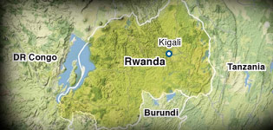

As in all wars and other conflicts, women have been tremendously affected in many ways. Whilst it would be so easy for them to question their future, feel sorry for themselves and perish in their loneliness, the women of Rwanda have picked up the pieces and moved on with their lives. They have taken the first step in reclaiming their future through hard work, reconciliation, improving their education and that of their children. They have realised that they don’t have to see the whole staircase, but all they need is to take that first step, a step that is within their means.
Why invest in these Women?
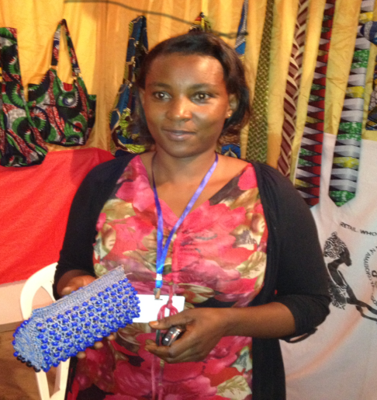
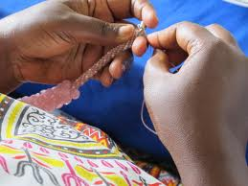
From being totally impoverished—lacking means to provide for her family, Rachel started with an equivalent of £5 borrowed from a friend, she made two bags which she sold and paid off her debt…..
“My challenge now is to find a market and to grow my business”

