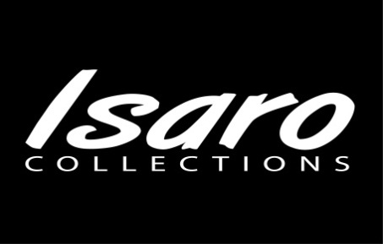

About Us

*Our Mission*

*Our Vision*

*Our Values*

*Where we are*

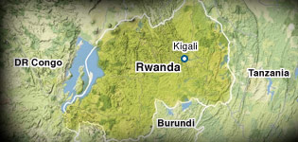 We’re a social enterprise created to promote and expand the design and creative hand work of destitute Rwandan women (widows and victims of the 1994 Genocide and other underprivileged groups in East and Central Africa).

General levels of instability in Africa have been high since the first wave of independence in 1960. Particulary this part of Africa (East and Central Africa), pervasive and persistent violence, Governments riddled with corruption and incompetence has confounded efforts to improve economic capacity and performance in the region.

As in all wars and other conflicts, women have been tremendously affected in many ways. Whilst it would be so easy for them to question their future, feel sorry for themselves and perish in their loneliness, the women of Rwanda have picked up the pieces and moved on with their lives. They have taken the first step in reclaiming their future through hard work, reconciliation, improving their education and that of their children. They have realised that they don’t have to see the whole staircase, but all they need is to take that first step, a step that is within their means.

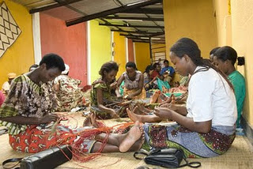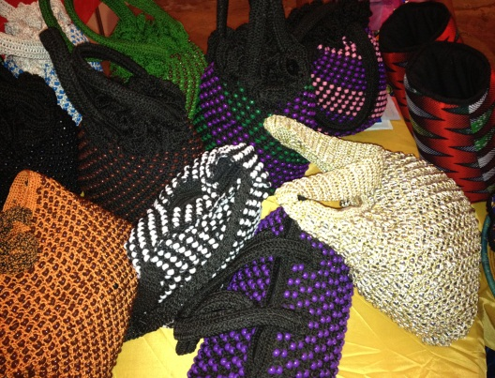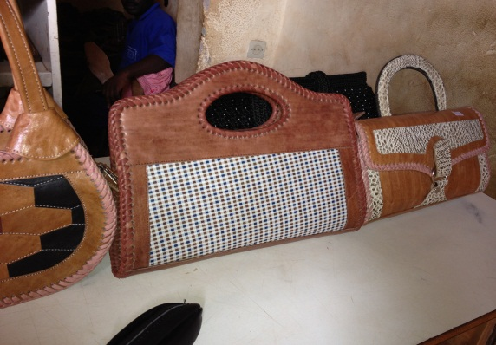

In March 2011, whilst in Rwanda, I had an opportunity to visit one of the associations of the artisan women in rural Rwanda. Most members of the group are survivors of the genocide; others are victims of rape and others are generally underprivileged and under

-represented. Some of the women’s skills have been passed down from one generation to another, from one community to another, and those skills are their main means of earning a living.

I was inspired by the skill, creativity, passion and commitment of these amazing women; however, I couldn’t help but notice the poverty behind the passion. As I chatted with one lady she explained that their biggest challenge to raise income is the small market. The country’s local market is small and a chance to sell their products abroad would help to widen their market and expand their opportunities.

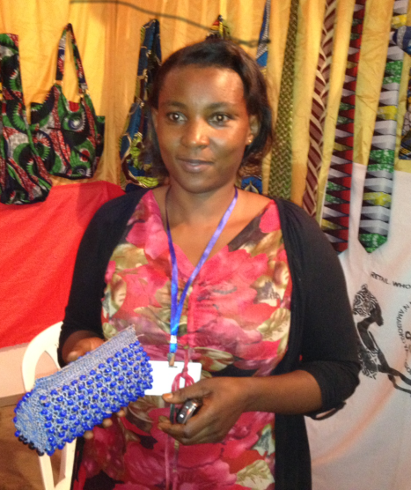  **Moving Beyond Dependence** 

From being totally impoverished—lacking means to provide for her family, Rachel started with an equivalent of £5 borrowed from a friend, she made two bags which she sold and paid off her debt…..

“My challenge now is to find a market and to grow my business”

®www.Isarocollections.com